EcoPackAI – AI-Powered Sustainable Packaging Recommendation System

FILE STRUCTURE:

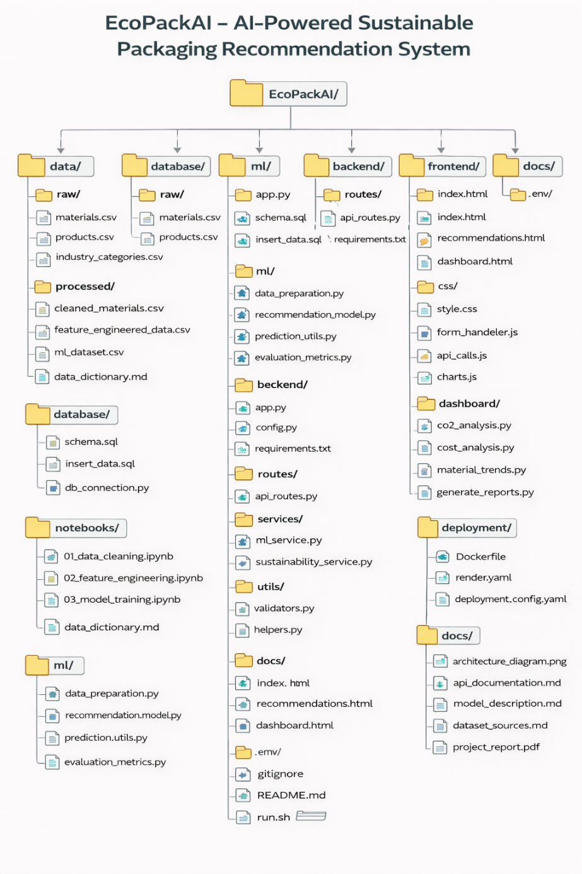

🔹 STEP 1: Project Setup & Folder Structure
Goal: Prepare workspace
- Create project root folder: EcoPackAI/
- Create folders as shown in the project structure image:
  - data/, ml/, backend/, frontend/, dashboard/, docs/, deployment/
- Create virtual environment
- python -m venv venv
- source venv/bin/activate # Windows: venv\Scripts\activate
- Install libraries
- pip install pandas numpy scikit-learn xgboost flask psycopg2 matplotlib seaborn joblib

🔹 STEP 2: Data Collection & Understanding (Milestone 1)
Files used:
✔ material.csv
✔ product.csv
material.csv contains:
- material_name
- strength
- carbon_emission_score
- cost
- biodegradability
- flexibility
product.csv contains:
- product_type
- industry_type
- weight
- fragility
📌 Action
- Place both CSV files in:
- data/raw/

🔹 STEP 3: Data Cleaning
Goal: Prepare clean data
- Load datasets using pandas
- Handle:
  - Missing values
  - Duplicate rows
- Normalize numerical columns:
  - strength
  - cost
  - carbon_emission_score
- Encode categorical columns:
  - material_name
  - product_type
  - industry_type
📌 Save cleaned files to:
data/processed/cleaned_materials.csv
data/processed/cleaned_products.csv

🔹 STEP 4: Feature Engineering
Goal: Create sustainability intelligence
Create new features:
- CO₂ Impact Index
- Cost Efficiency Score
- Material Suitability Score
📌 Example logic:
Material Suitability Score =
(strength + flexibility + biodegradability)
– (carbon_emission_score + cost)
📌 Save final ML dataset:
data/processed/ml_dataset.csv

🔹 STEP 5: Machine Learning Dataset Preparation (Milestone 2)
Goal: Prepare data for training
- Select features (X):
  - strength
  - flexibility
  - biodegradability
  - weight
  - fragility
- Targets (y):
  - cost
  - carbon_emission_score
- Split dataset:
  - 80% Training
  - 20% Testing
- Apply scaling (StandardScaler)

🔹 STEP 6: Train ML Models
Models required (as per PDF):
✔ Model 1: Cost Prediction
- Random Forest Regressor
✔ Model 2: CO₂ Prediction
- XGBoost Regressor
📌 Evaluate models using:
- RMSE
- MAE
- R² Score
📌 Save models:
ml/saved_models/cost_model.pkl
ml/saved_models/co2_model.pkl

🔹 STEP 7: Recommendation Engine
Goal: Rank materials intelligently
- Take product input:
  - product_type
  - weight
  - fragility
- Predict:
  - cost
  - CO₂ footprint
- Rank materials using:
  - Low CO₂
  - Low cost
  - High strength
- Return Top 3 recommended materials
📌 File:
ml/recommendation_engine.py

🔹 STEP 8: Flask Backend API (Milestone 3)
Goal: Connect ML to UI
APIs to create:
- /predict
- /recommend
- /analytics
Flow:
Frontend → Flask API → ML Model → Response
📌 Files:
backend/app.py
backend/routes/
backend/services/

🔹 STEP 9: Frontend UI
Goal: User interaction
Pages:
- Product Input Form
- Material Recommendation Table
- Sustainability Analytics
Tech:
- HTML
- CSS
- Bootstrap
- JavaScript (fetch API)
📌 Folder:
frontend/

🔹 STEP 10: BI Dashboard (Milestone 4)
Goal: Sustainability insights
Charts:
- CO₂ reduction %
- Cost savings
- Material usage trends
Tools:
- matplotlib / plotly
Exports:
- PDF
- Excel
📌 Folder:
dashboard/

🔹 STEP 11: Deployment
Goal: Make it live
- Create Dockerfile
- Add requirements.txt
- Deploy on:
  - Render / Heroku
- Connect PostgreSQL (optional)
📌 Folder:
deployment/

🔹 STEP 12: Documentation & Final Submission
Goal: Evaluation ready
Prepare:
- README.md
- Architecture diagram
- Project report
- Demo screenshot

TEAM MEMBERS AND OUR ROLES:

